SchulArena-Webquest: Crossing Frontiers
passend zu: Open World 1 Unit 6 / Crossing Frontiers (oder lehrmittelunabhängig einsetzbar)
- Download the document and save it on your computer.
- Write the answers and/or post the pictures onto this sheet.
- Print it out when you have finished and bring it to class.

- Station one: James Cook
You need:
- http://www.captaincooksociety.com/home
Find out with the website above:
Who was Charles Green?
Which one was the smallest of Cook’s Pacific ships?
Where and how did Cook die?
What can be seen on this picture?
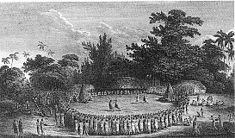
What is the name of this bay? Where is it? Who was the first explorer there? (Tipp: Australia)
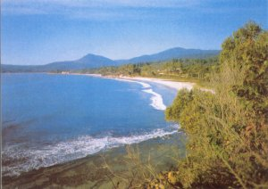

- Station two: Crash course J. Cook
You need:
- http://www.youtube.com/watch?v=2yXNrLTddME&feature=fvsr

This is quite a fast speaker… ;-)
Try to understand four new facts (things that you did not know before) about J. Cook and write the down:
…………………………………………………………………………………………………………………………………………….
…………………………………………………………………………………………………………………………………………….
…………………………………………………………………………………………………………………………………………….
…………………………………………………………………………………………………………………………………………….
…………………………………………………………………………………………………………………………………………….
…………………………………………………………………………………………………………………………………………….
…………………………………………………………………………………………………………………………………………….

- Station three: Antarctica
You need:
http://www.enchantedlearning.com/school/Antarctica/
Do the quiz first. You will only get a correct picture if all your answers are correct.
Copy the picture (print screen or snipping tool) into this rectangle and cut it to size.

- In question six of the quiz they say that the coldest temperature record was -128.6 °F. Find a converter on the internet and give the temperature in °C: ___________________

- Work with the same website and find out:
Who was the first person who reached the South Pole? _______________________
What nationality was he? _______________________

Complete this sentence:
The Antarctica _________________ from the __________________ to the place where it is today. The drifting started ______________ million years ago. The continent once was together with ____________________. That was the time when _________________ lived there.

Jokes: Find the answers:
What did the sea say to the iceberg? ______________________________________________
What do penguins eat for lunch? __________________________________________________
Who is the penguins favourite aunt? _______________________________________________
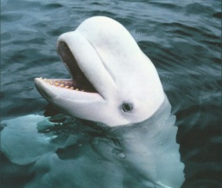
Which of these are Antarctic animals? Circle them.
