Animal world

a) Geeez... I’m so hot... I’m bacon!

b) I really hate blind-dates!

c) So…do you want the grapes or the worm?

d) Of course it’s milk. What did you expect?

e) I really like coming here because you let me up on the couch.

f) Wow! Food on wheels..!

g) Come out you coward!
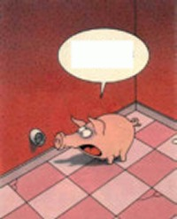
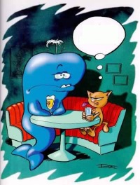
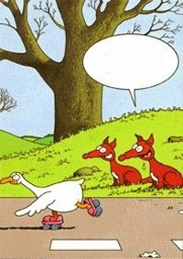
1
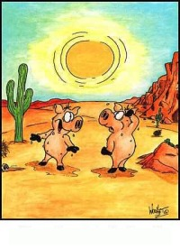
3
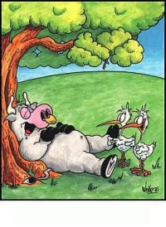
2

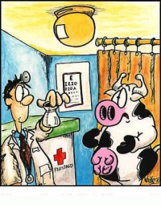
4

6 7

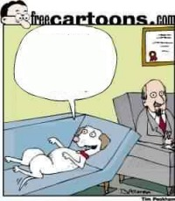
5

