HAPPY X-MAS

a) Right – I’m going to ask you again nicely: Let go?

b) The day the elves won the lottery.

c) Where icicles come from…

d) I couldn’t find any carrots for the nose, so I grapped this
from my mom’s drawer.

e) Oh that felt sooo good. Whip me, whip me harder and
pull my reins again.

f) I stopped a bit too quickly and Santa wasn’t wearing a seatbelt.

2 3
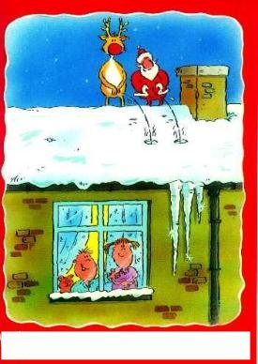
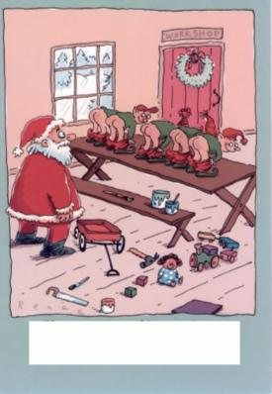
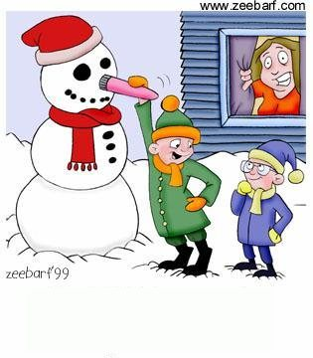
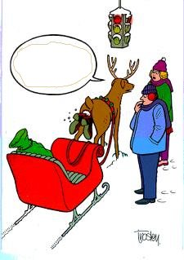
1

4 5
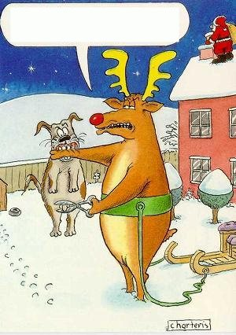
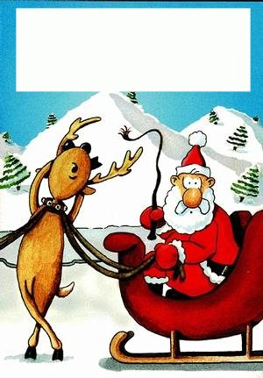
6

