Computers for a better life...

- Hi, we hope you feel like at home..!

- He is probably not compatible…

- Oh, three times wrong password, huh…?!

- Ok, I’ve closed all windows now. Can I restart my computer now?

- Ok, you’ve won the bet; your Pentium is faster.

- We’ve located the problem… it’s a defective user.


3

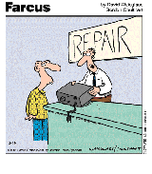
1 2


4


5 6

