


1
2
3
I t was a good idea to send your husband. Mine couldn’t carry more than two.

4
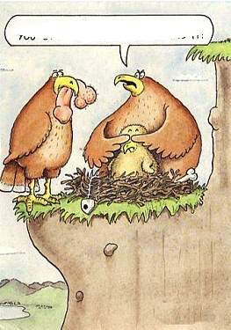
6
5

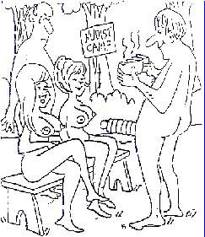

I said., I think you’ve got your swimsuit on backwards.

Ah! There you are...
No, you can’t play with mine, just ‘cause you’ve broken yours off.
I’ve been replaced by a computer at work and a vibrator at home.
I don’t care where you got it – she’s not eating it!

