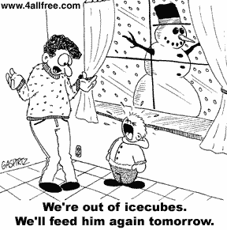
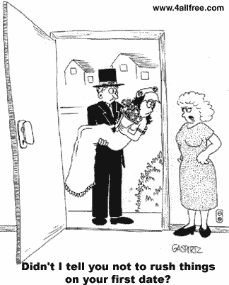
1
2

3
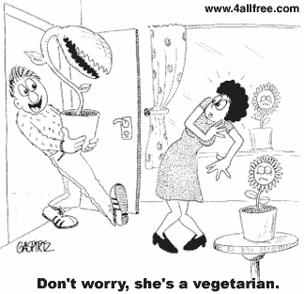
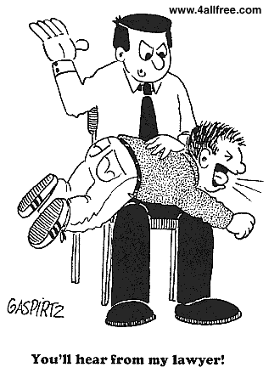
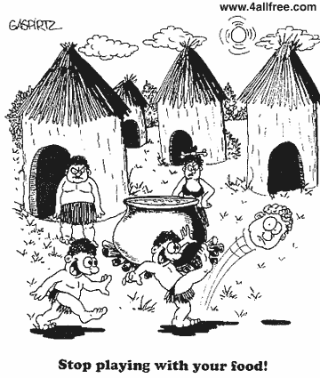
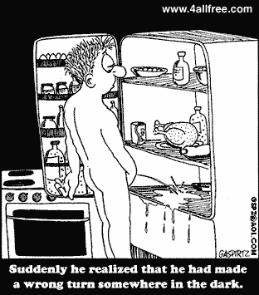
4

6

5

Didn’t I tell you not to rush things on your first date?

Stop playing with your food!
You’ll hear from my lawyer!
Don’t worry! She’s a vegetarian.
We’re out of icecubes. We’ll feed him again tomorrow.
Suddenly he realized that he had made a wrong turn somewhere in the dark.

