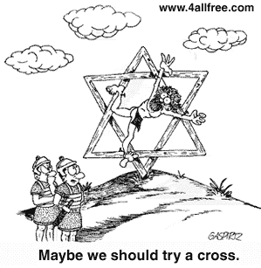
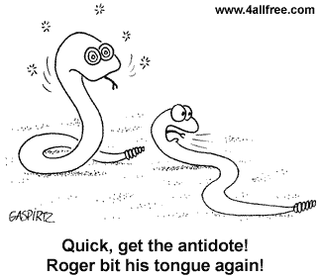
1
2

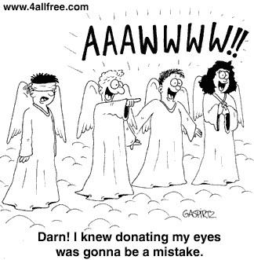
3
4
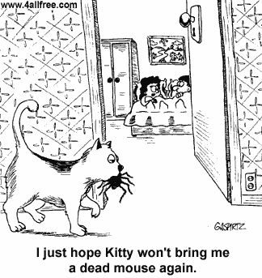

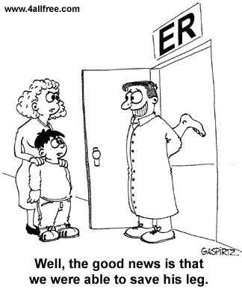
6
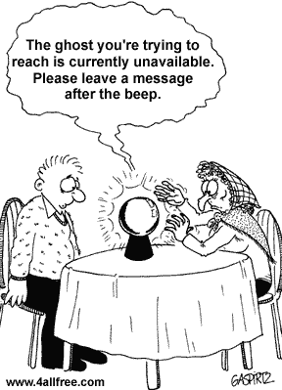
5

Darn! I knew donating my eyes was gonna be a mistake.
I hope Kitty won’t bring me a dead mouse again.
The ghost you’re trying to reach is currently unavailable. Please leave a message after the beep.
Well, the good news is that we were able to save his leg.
Maybe we should try a cross.
Quick, get the antidote! Roger bit his tongue again!

