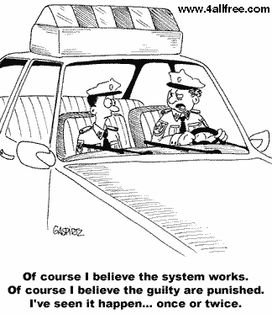
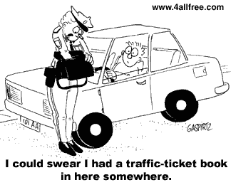
2
1

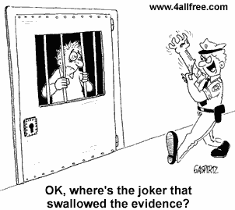
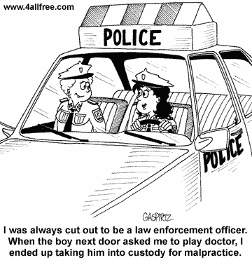

4
3

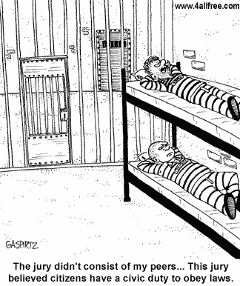

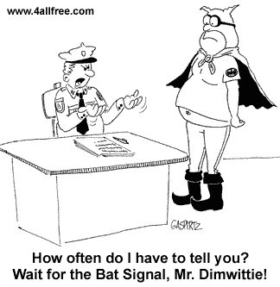
5
6

Ok, where is the man, who swallowed the evidence?

I could swear I had the traffic-ticket book in here somewhere.
Of course I believe the system works. Of course I believe the guilty are punished. I’ve seen it happen once or twice…

I always cut out to be a law enforcement officer. When the boy next door asked me to play doctor, I ended up taking him into custody for malpractice.

The jury didn’t consist of my peers...This jury believed citizens have a civic duty to obey laws.
How often do I have to tell you? Wait for the Bat Signal, Mr. Dimwittie!

