Sports – ready, steady, go...!

- I don’t want to mention any names, but one of you isn’t giving 100% out there.

- After these celebrations, Stuart Pierce became a woman.

- Watch out for this guy’s head butt!

- ‘Scuse me coach… Are we the hugs or the kisses?

- The new Olympic discipline: Smogging.

- You’ve a powerful shot, but a bit imprecise.

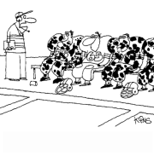
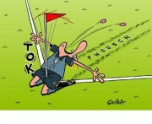
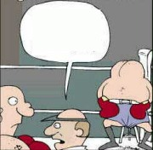
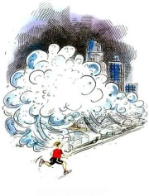
3

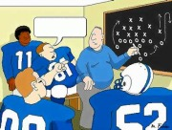
1 2

4 5
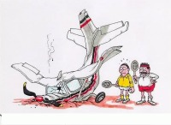
6

